Suggested solution to assignment 2
- On February 15, 2005, the Gallup Organization released the results of a Gallup UK poll regarding Internet usage in Great Britain. Each of 1,009 randomly selected UK adults was asked to respond to the following question:
How much time, if at all, do you personally spend using the Internet-more than an hour a day, up to one hour a day, a few times a week, a few times a month or less, or never?
The poll’s results were as follows: More than an hour a day (22%); Up to an hour a day (14%); A few times a week (15%); A few times a month or less (10%); Never (39%). Use these data to construct a bar chart and a pie chart.
Solution:

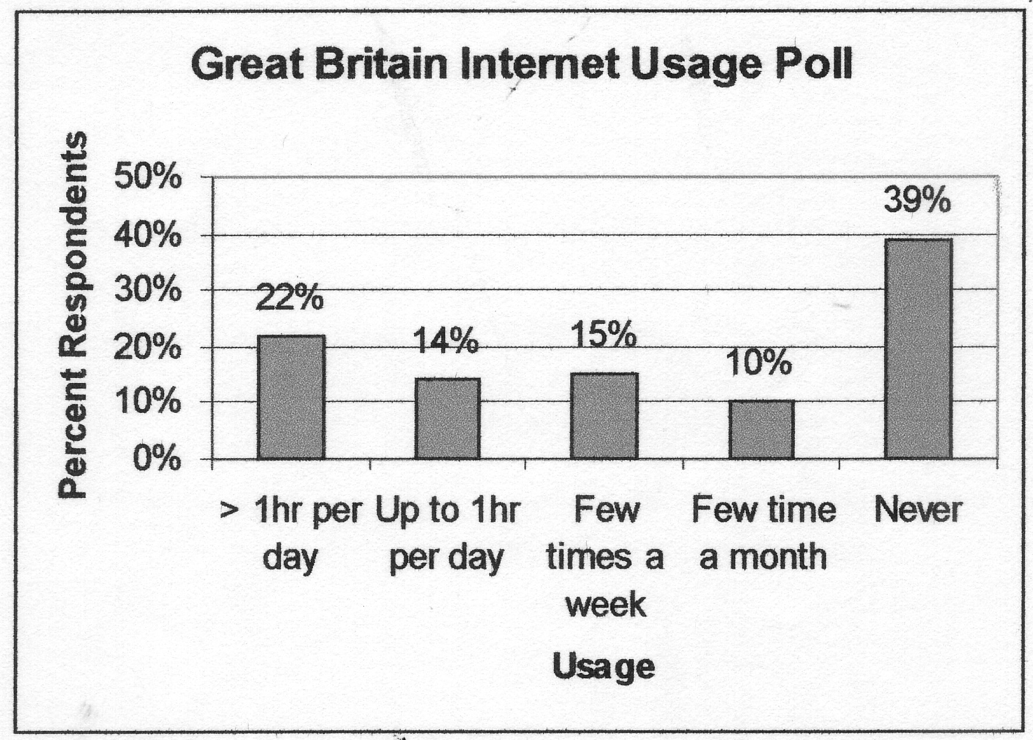
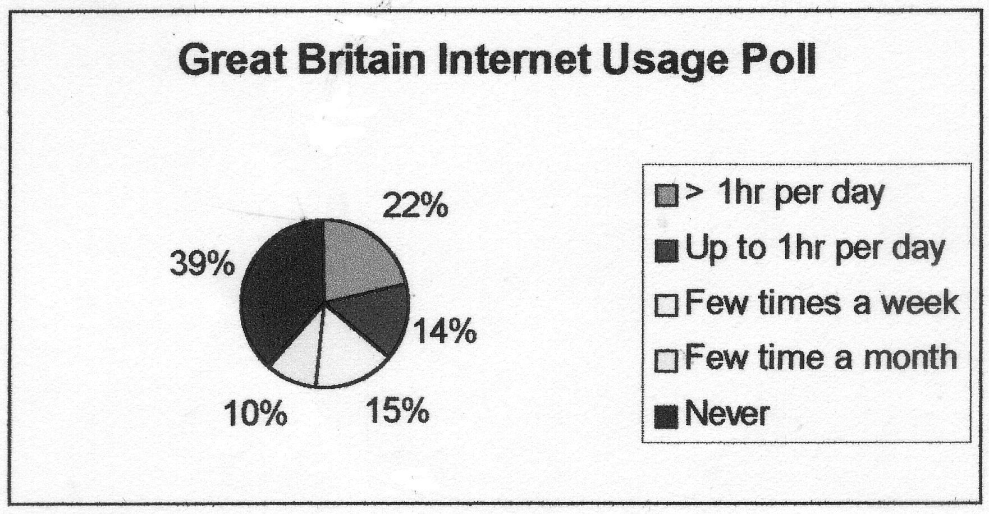

- Thirteen internists in the Midwest are randomly selected, and each internist is asked to report last year’s income. The incomes obtained (in thousands of dollars) are 152, 144, 162,154, 146, 241, 127, 141, 171, 177, 138, 132, 192, 188, 101 . Find :
  - The 90th percentile.
  - The median.
  - The first quartile.
  - The third quartile
  - The 10th percentile.
  - The interquartile range.
  - Develop a five-number summary and a box-and-whiskers display.
Solution:
First order the number from smallest to largest.
101,127,132,138,141,144,146,152,154,162,171,177,188,192,241

- i=13.5, Q=192
- Median is 152
- i=15*1/4=3.75, Q1=138
- i=15*3/4=11.25, Q3=177
- i=15*1/10=1.5, Q=127
- IQR=Q3-Q1=177-138=39
g.
 | Income (1000's)
minimum | 101
maximum | 241
1st quartile | 138.00
median | 152.00
3rd quartile | 177.00
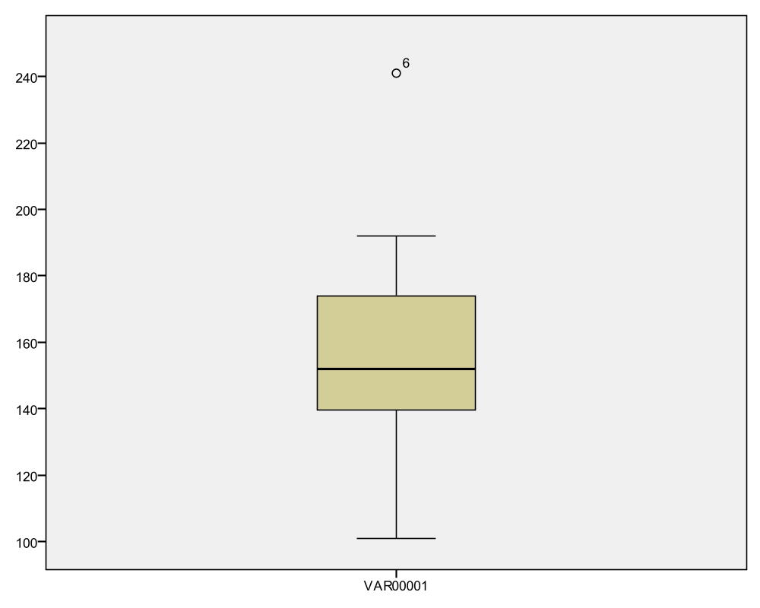
- According to the Morningstar.com website, the 2004 total return percentages for several popular funds were as follow:
Fund | 2004  Total Return%
Vanguard 500 Index | 10.7
Wasatch Core Growth | 21.7
Fidelity Stock Selector | 9.9
Fidelity Dividend Growth | 6.0
Janus Worldwide | 5.2

Suppose that an investor had $100,000 invested in the Vanguard 500 Index fund, $500,000 invested in the Wasatch Core Growth fund, $500,000 invested in the Fidelity Stock Selector fund, $200,000 invested in the Fidelity Dividend Growth fund, and $50,000 invested in the Janus Worldwide fund.
a. Compute a weighted mean that measures the 2004 average total return for the investor’s portfolio.
- Compare your weighted mean with the un-weighted mean of the five total return percentages. Explain why they differ.
Solution:
a. 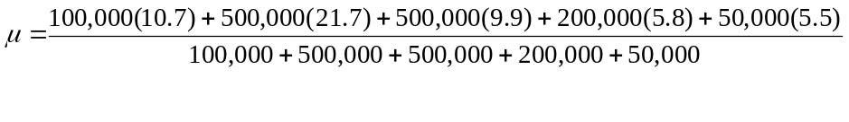 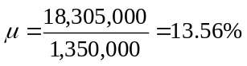
- Un-weighted mean = 10.72%
The investor put more money in Wasatch Core Growth fund, so the return of this fund should be consider more. Then the weighted mean is greater than the un-weighted mean.
- As given on the Morningstar website, the mean return for Fidelity Leveraged Company Stock is 17.98 percent with a standard deviation of 10.02 percent, while the mean return for Baron Opportunity Retail Stock is 16.43 percent with a standard deviation of 12.23 percent. Which stock do you buy? (Which is riskier than the other one?)
Solution：coefficient of variation=
The coefficient of variation of fidelity Stock is = (10.02/17.98)*100=55.7
The coefficient of variation of baron stock is= (12.23/16.43)*100=74.4
The baron stock is riskier than fidelity Stock. I will buy fidelity Stock.

